RatCVS - Rat Cardiovascular System Simulation
Copyright © 1996-2012 J. Dempster, University of Strathclyde

Table of Contents
Introduction 2
Rat Cardiovascular System Preparation 3
Receptors 4
Using the Simulation 5

Introduction

RatCVS is a simulation of a pithed rat experimental preparation for investigating the actions of drugs on the heart and cardiovascular system.

"Pithing" refers to the destruction of spinal cord pathways, severing all the nerve connections between the brain and the cardiovascular system.. This greatly simplifies the interpretation of experimental results by removing the central baroreceptor reflexes.

The simulation allows you to observe traces of blood pressure, left ventricular pressure, venous pressure, heart rate and contractile force on a simulated chart recorder, to apply a variety of different drugs, and to observe their effects

Next

Rat Cardiovascular System Preparation

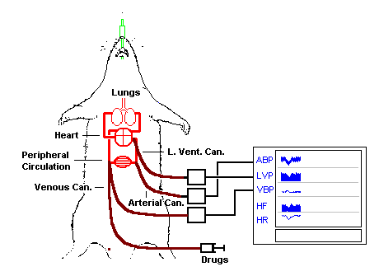
A rat is anaesthetised and artificially ventilated. Three cannulae are inserted into the femoral artery, vein and the left ventricle of the heart.

The arterial cannula is connected to a pressure transducer to measure arterial blood pressure. Traces of arterial blood pressure (ABP) and heart rate (HR), computed from ABP, are recorded on the chart recorder.

The left ventricular cannula is connected to a second pressure transducer and used to produce a trace of left ventricular pressure (LVP). A measure of the contractile force of the heart (HF) is derived from the LVP.

The venous cannula is connected to a third pressure transducer and used to produce a trace of central venous blood pressure (VBP). Drugs can also be injected into the animal via the venous cannula.

A specially designed pithing rod can be passed down the spinal cord of the animal destroying all nerve connections with the brain, and hence disabling the central blood pressure reflexes associated with the carotid artery baroreceptors.

Next

Receptors

Heart

The heart has both muscarinic cholinoceptors (mAchR), beta1-adrenoceptors and adenosine receptors.

Muscarinic stimulation results in a reduction in heart rate (H.R.) and stroke volume (S.V.) and causes a reduction in blood pressure. Adrenergic stimulation results in an increase in H.R., and S.V.

Blocking calcium channels in heart muscle causes a reduction in H.R. and S.V.

Blood vessels

Alpha1-adrenoceptors on blood vessels cause vasoconstriction, increasing peripheral resistance.

Beta2-adrenoceptors on blood vessels cause vasodilation.

Agents which open smooth muscle potassium ion channels cause vasodilation.

Nitrovasodilators cause vasodilation by generating nitric oxide.

Angiotensin I is converted to angiotension II and causes vasoconstriction

Next

Using the Simulation

1) Select New Rat from the File menu, to clear the chart.

2) Click the Start button to start the chart recorder running.

3) To inject a drug into the animal’s circulation :
a) Select a drug from the Standard Drugs menu.
b) Select the required dose from the list of doses.
c) Click Inject Drug button to add the drug.

4) You can make quantitative measurements from the traces by moving the mouse cursor over the trace and noting the value in the readout at the bottom of the screen.

5) You can add as many doses and/or drugs as necessary. When you have finished your experiment, click the Stop button to stop the chart.

6) To print out a hard copy of the traces shown on the screen, Select Print from the File menu.

7) When you have completed an experiment you can save it to a storage file by selecting Save Rat ... from the File menu. (To re-load an experiment, select Load Rat ...).

8) To exit from the simulation program, select Exit from the File menu.

